Communications in Membership Tool Kit

Newsletter
For most communications, use the Newsletter. This lets you draft a document, assign a list of recipients (communications list), and schedule the release. Here are instructions for sending a newsletter.

Attachments
MTK does not let you attach documents to newsletters or emails. You can however, include links to files. Instructions are here.

Email individuals
You can also select names from the directory and send an email to them. For instructions, please read this.
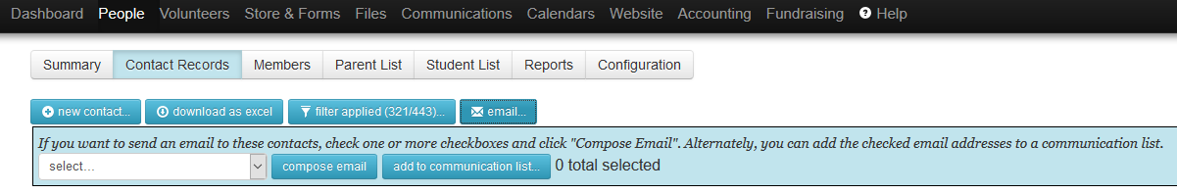

Communications Lists
Room Parents will need to create a Communications List for their individual classroom.

To create a new list, login to MTK. From the dashboard, go to Communications, then Communications Lists and click Add List.
- Assign the list name and public name to identify the list.
- Assign the Default From Name and Email address. This is what the recipients will see when they get the email. One Room Parent will need to be designated as the default From Name and Email Address.
- For Subscription Method, choose Anyone or Private. The PTO doesn’t have Membership implemented, so nobody is a member.
- Automatic Add conditions. You can select properties like Grade, Teacher, etc.
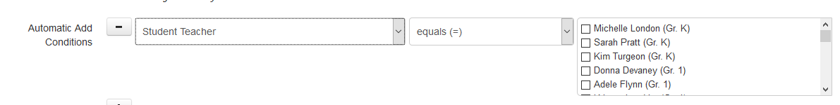
- Automatically Remove if conditions no longer match? Choose Yes.
- Who To Add? Choose Automatically Add Parent Email Addresses Only. This should include both the primary and secondary email address. No students are assigned email addresses.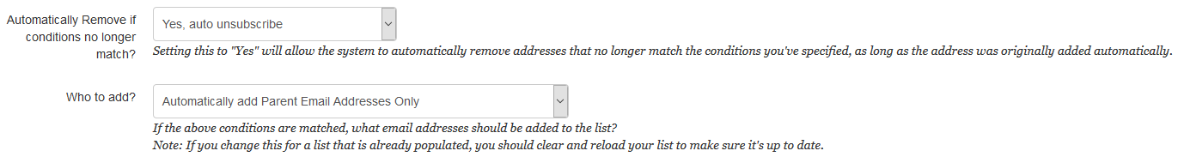

Links to MTK Help
Communications Lists:
https://help.membershiptoolkit.com/portal/kb/articles/setting-up-a-communication-list

Send Newsletter:
https://help.membershiptoolkit.com/portal/kb/articles/sending-a-newsletter-start-to-finish

Customize a Newsletter (Attach a PDF or video, add anchor tags):
https://help.membershiptoolkit.com/portal/kb/articles/customizing-newsletters

Send Email:
https://help.membershiptoolkit.com/portal/kb/articles/sending-an-email-to-your-contacts

